|  |  |  |  |
| --- | --- | --- | --- |
| **Distance_front** | **Distance_rear** | **Warning** | **Brake** |
| 5 | 5 | 1 | 1 |
| 5 | 20 | 1 | 1 |
| 20 | 5 | 1 | 0 |
| 20 | 20 | 0 | 0 |

# **Dangerously close to both front and rear:**

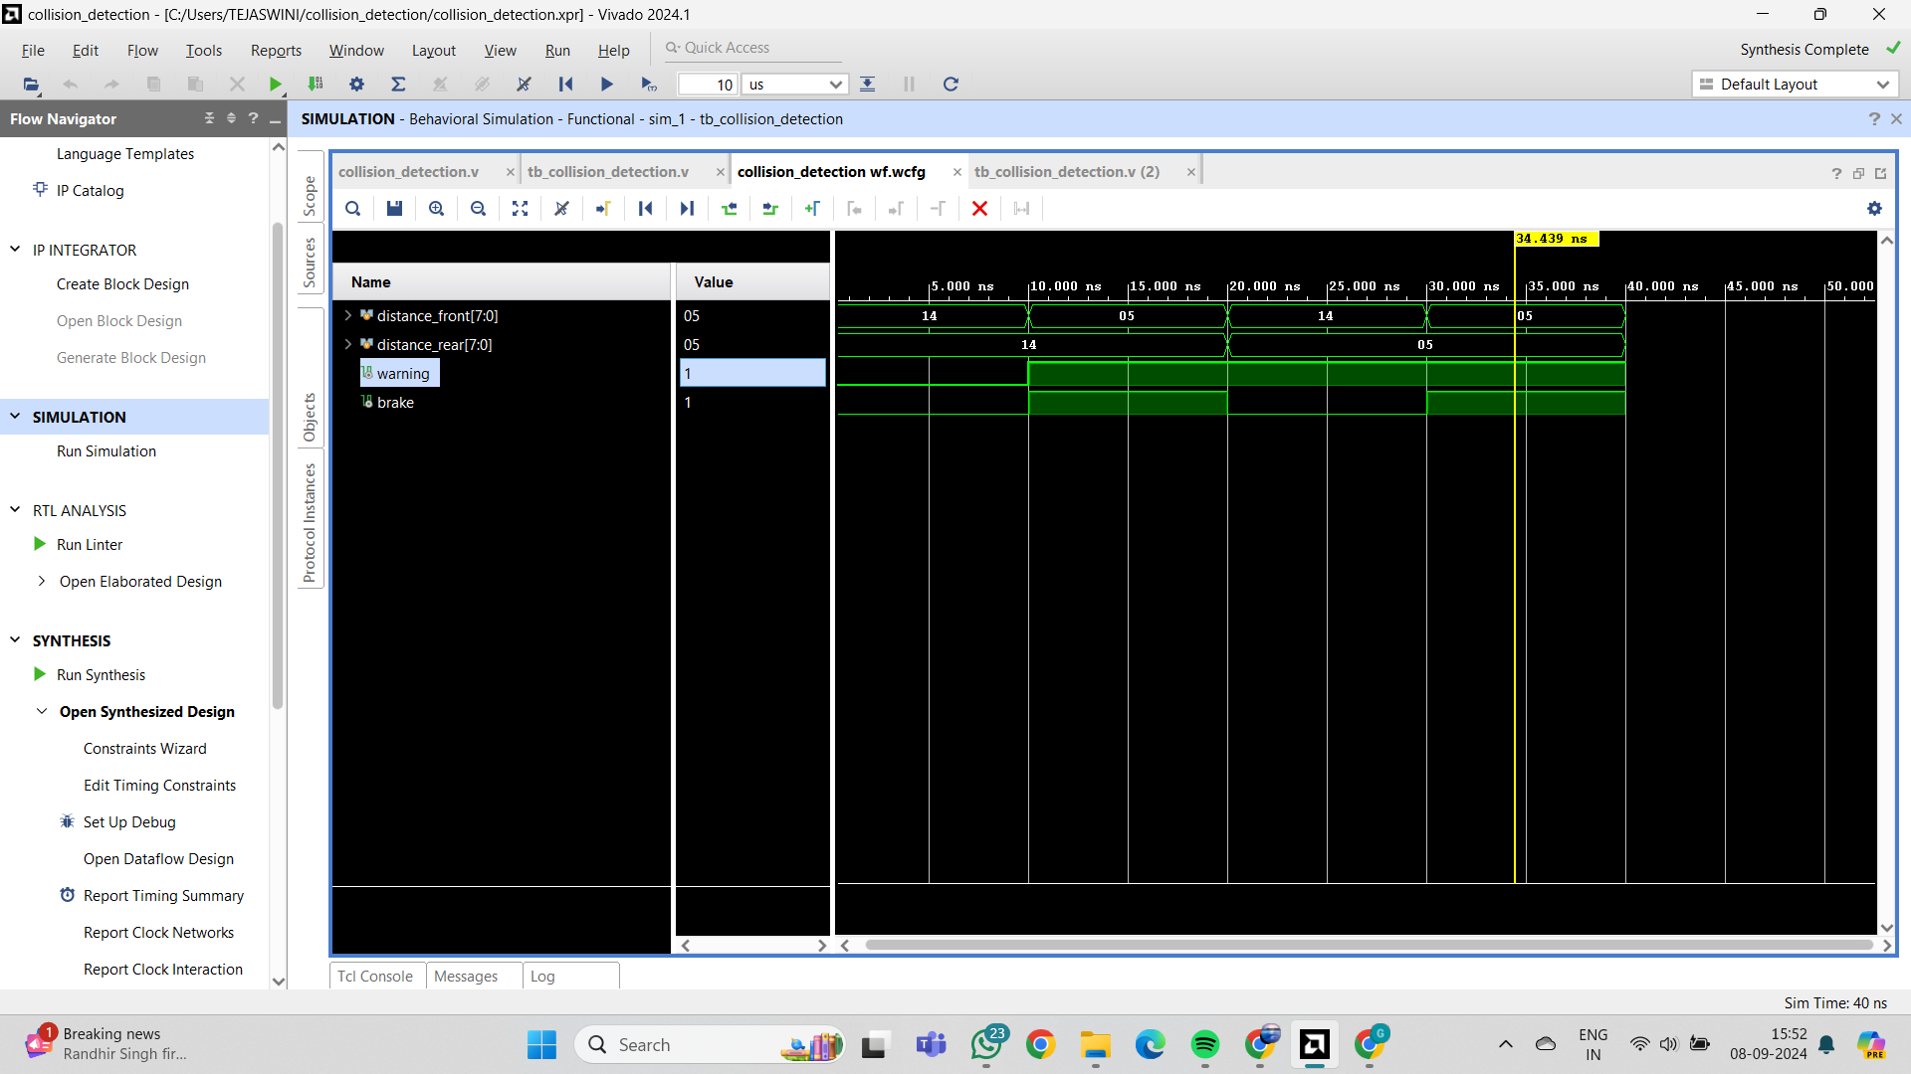

**Close to the front vehicle:**

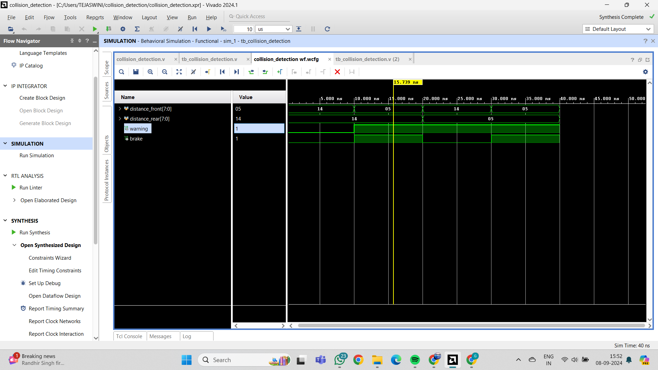

**Close to the rear vehicle:**

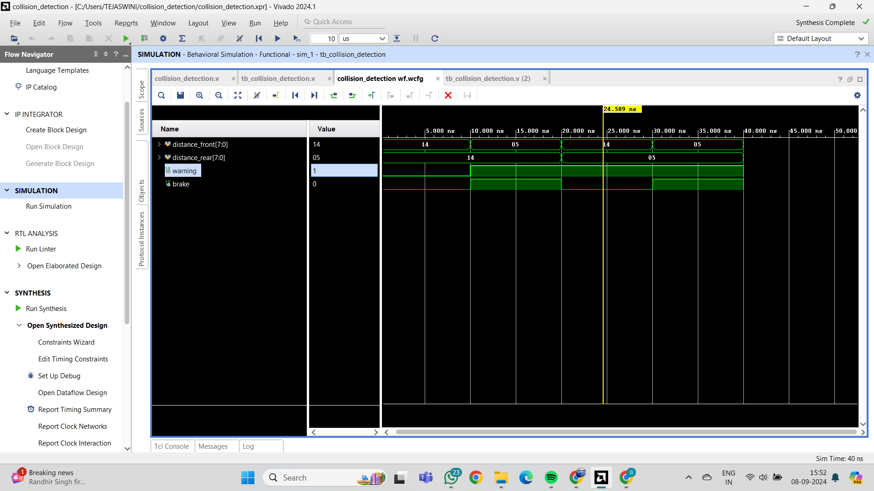

**Both are at safe distances:**